**Self-test: TCP**

1. Suppose that Host A has received all bytes numbered 0 through 535 from B and suppose that it is about to send a segment to Host B. *What should be the acknowledge number of the segment it sends to B?*
2. Suppose that Host A has received one segment from Host B containing bytes 0 through 535 and another segment containing bytes 900 through 1,000. For some reason Host A has not received bytes 536 through 899. In the next segment sent from A to B, *what should be the value of the acknowledge number field?*
3. Assume that ISN = 0 on both sides. In terms of the sequence and acknowledge numbers, SYNs count as 1 byte, as do FINs. Can you calculate the *seg* and *ack* values of each segment?

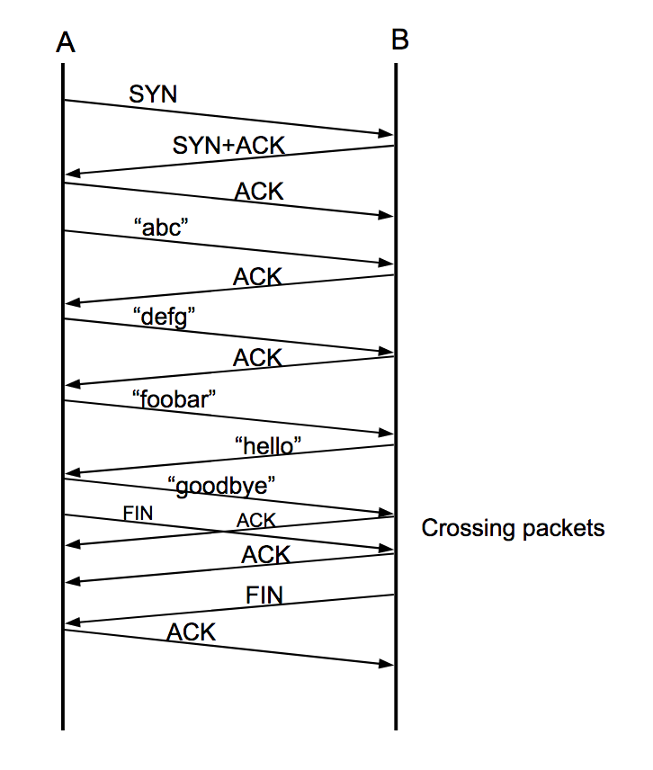

1. What is receive window *rwnd*? How does the connection use the variable *rwnd* to provide the flow control service?
2. What is congestion window *cwnd*? How to tune the value of *cwnd* in slow start and congestion avoidance modes, respectively? When should the connection transition from slow start mode into congestion avoidance mode, and vice versa?
3. What are the limitations of TCP?